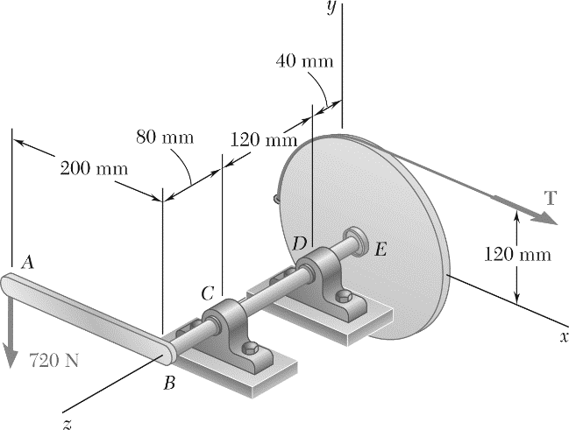

A 200-mm lever and a 240-mm-diameter pulley are welded to the axle *BE* that is supported by bearings at *C* and *D*.

If a 720-N vertical load is applied at *A* when the lever is horizontal and assuming that the bearing at *D* does not exert any axial thrust, determine

(*a*) the tension in the cord,

(*b*) the reactions at *C* and *D*.

**STATICS** ***UDM ENGR 3120*** - ***BUCT MEC 1701-1703*** ***CHAPTER 4 – Equilibrium of Rigid*** ***Bodies*** Student Name……………….........

ASSIGNMENT # 4-2 Due on 16/12/19 Student # …………… Name ………………………….